Creating a contact sheet in Adobe Bridge CS5
Contact sheets are what photographers used to create directly from their negatives, so that they could quickly and inexpensively decipher successful images from an entire shoot. Even though we are now shooting on digital, this format is still a valuable way at not only displaying your entire shoots on your weeblys, but it also enables you to quickly assess the quality of your images. You should always upload large photo shoots using this method.

- Open up “Adobe Bridge CS5” and find your file containing your images, using the folders on the left hand side:
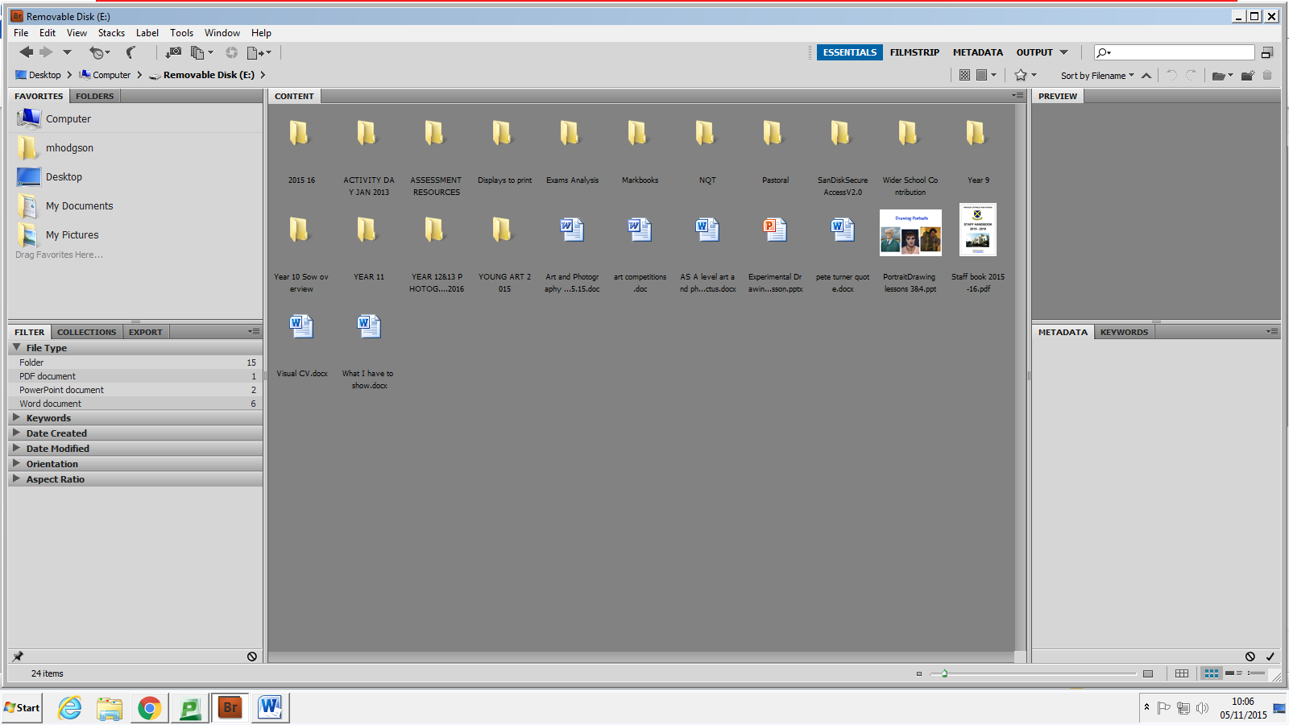

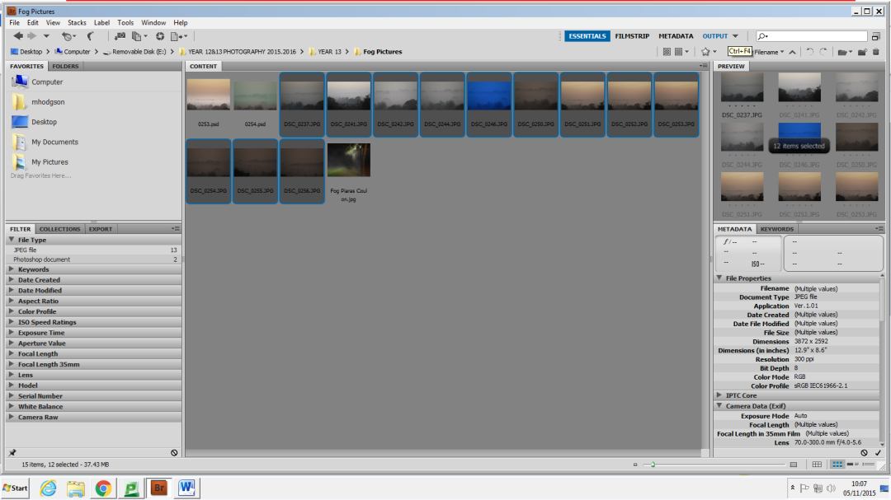
- Select the photographs you want to include in your contact sheet, and then click on the “output” icon in the top right of the screen:

- On the right hand side of this new page there are different lay out controls. For a contact sheet, you must make sure the PDF icon is highlighted, and then click on the “template” drop down menu and select either of the contact sheet options: 4 x 5 or 5 x 8 (number of pictures across by down on an A4 sheet of paper). Once selected, click “refresh preview” to check the layout of your contact sheet: 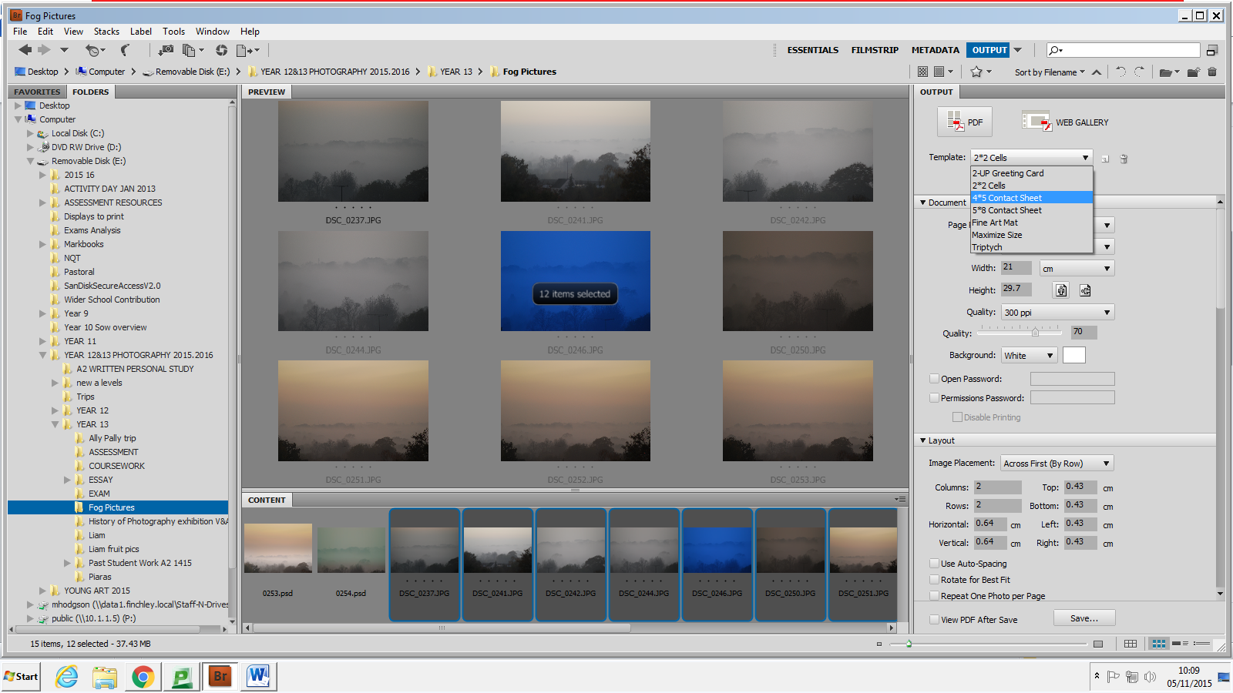

- If all is satisfactory, click “save” 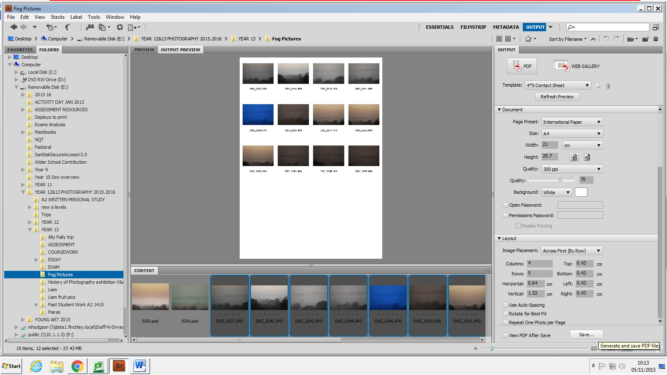

- This will save your contact sheet(s) as a PDF file, which Weebly cannot read, so you must open this new file up in Photoshop and save it again as a JPEG. You can then upload each sheet as individual images.

