How to create a Qi Wei inspired GIF:

- Open your photo in Photoshop and duplicate the background layer.
- Use the “Polygonal lasso tool” to draw an angular selection over were you want your first line to be.

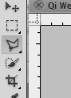

- With your selection still active, create a “mask layer” onto your top layer by clicking on this icon – you should see your mask is black with a white strip the size of your selection in your mask icon.

- Click on to the fx icon at the bottom of your layer panel, and select the “blending options”. Click down to the “colour overlay” and choose the colour you wish to tint your section with. As I am starting in the middle near the sun, I am going to start with sunset colours. Take the opacity down and make your “blending mode” colour.

- Within the same box, click on “gradient overlay” and set your settings to match mine. This is to add a slight tone to your selection to stop it looking flat.
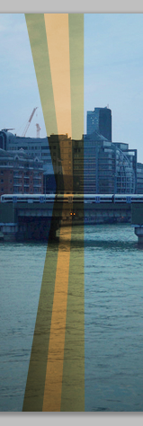
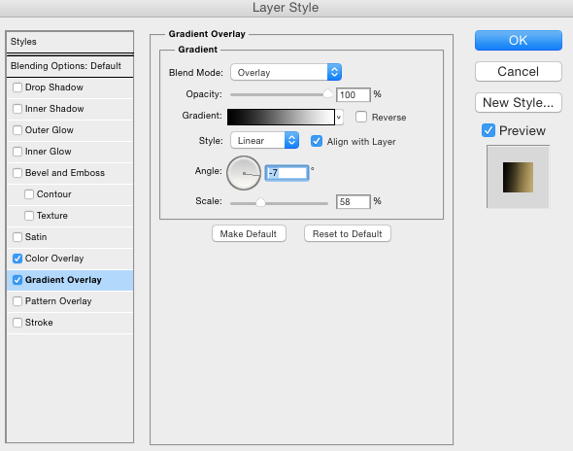

- Now, create another duplicate of the background layer, and repeat step 2 but make your selection slightly bigger than your first one. Complete step 2 and repeat all other steps, making sure you choose a different colour overlay for each selection. Use mine as inspiration and create a sunset effect.
