How to make a GIF in Photoshop

- Open the files you wish to include in your animation in Photoshop.
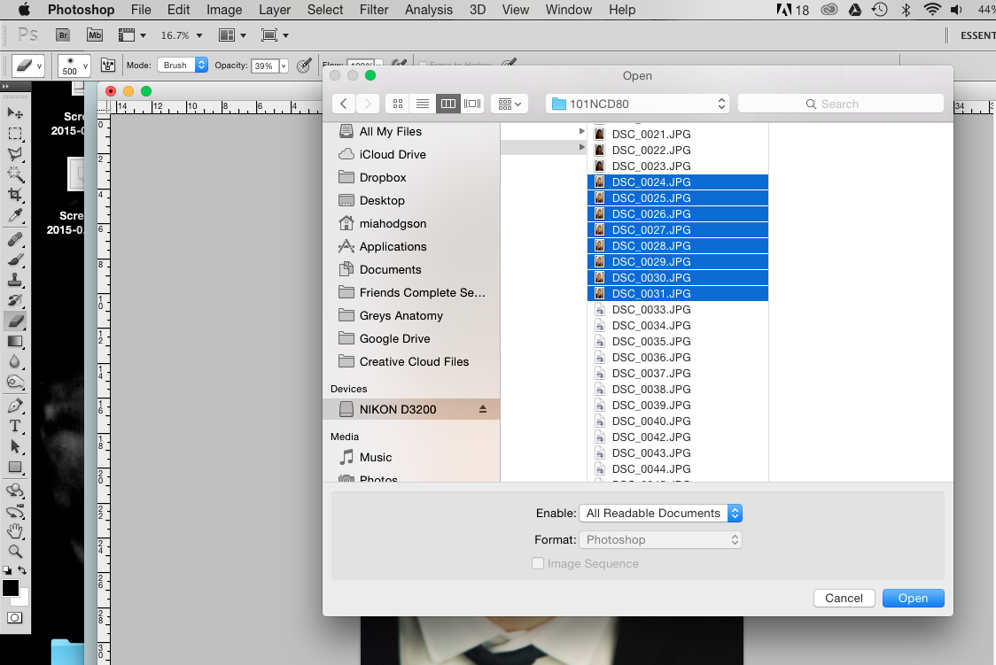

- Using the “move” tool (top of your toolbar on the left), drag and drop all the files into one.

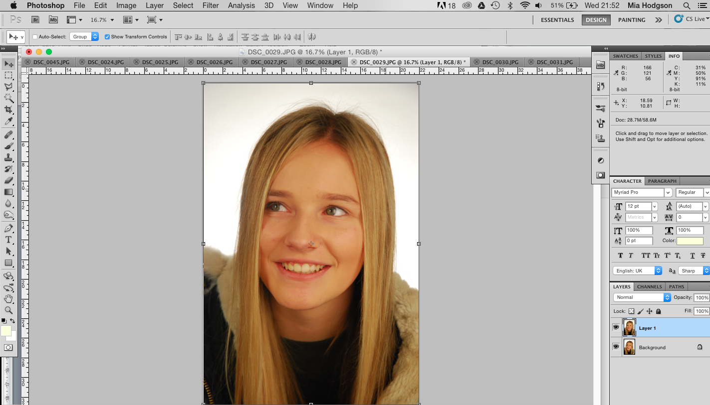
- It is important for your images to fit onto one another in a way that makes a fluid and accurate motion when the images are animated. Take the opacity of your top layer down to about 50% so that you can see the layer underneath it, and then using the move tool again position your image so that it fits onto the one beneath it.

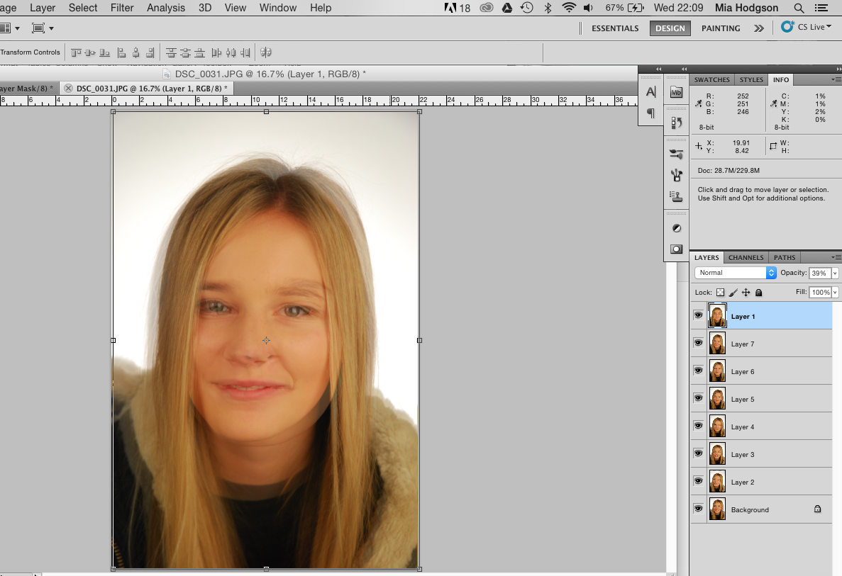

- If you want to edit your photos, you can add adjustment layers to the top of your layers, and they will affect every layer. This is perfect if you need to perform the same alterations to every photo, i.e. if you simply need to adjust the tone and contrast as I have done below.
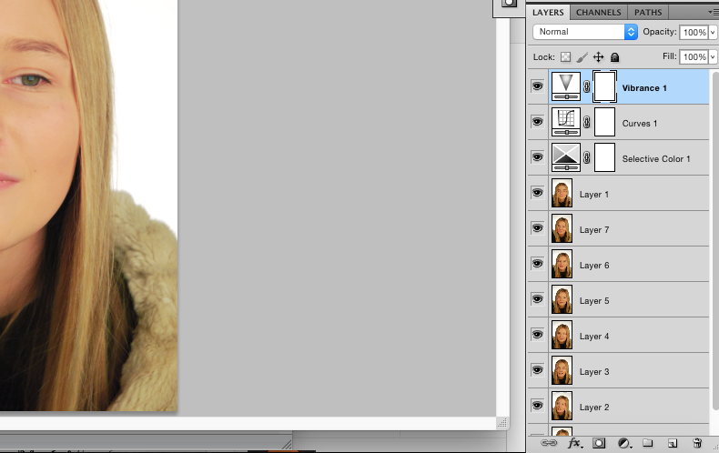

- Now to create your GIF – go to the top of your screen and select “window” and choose “animation”. A new frame window will appear on the bottom of your screen, as pictured below.
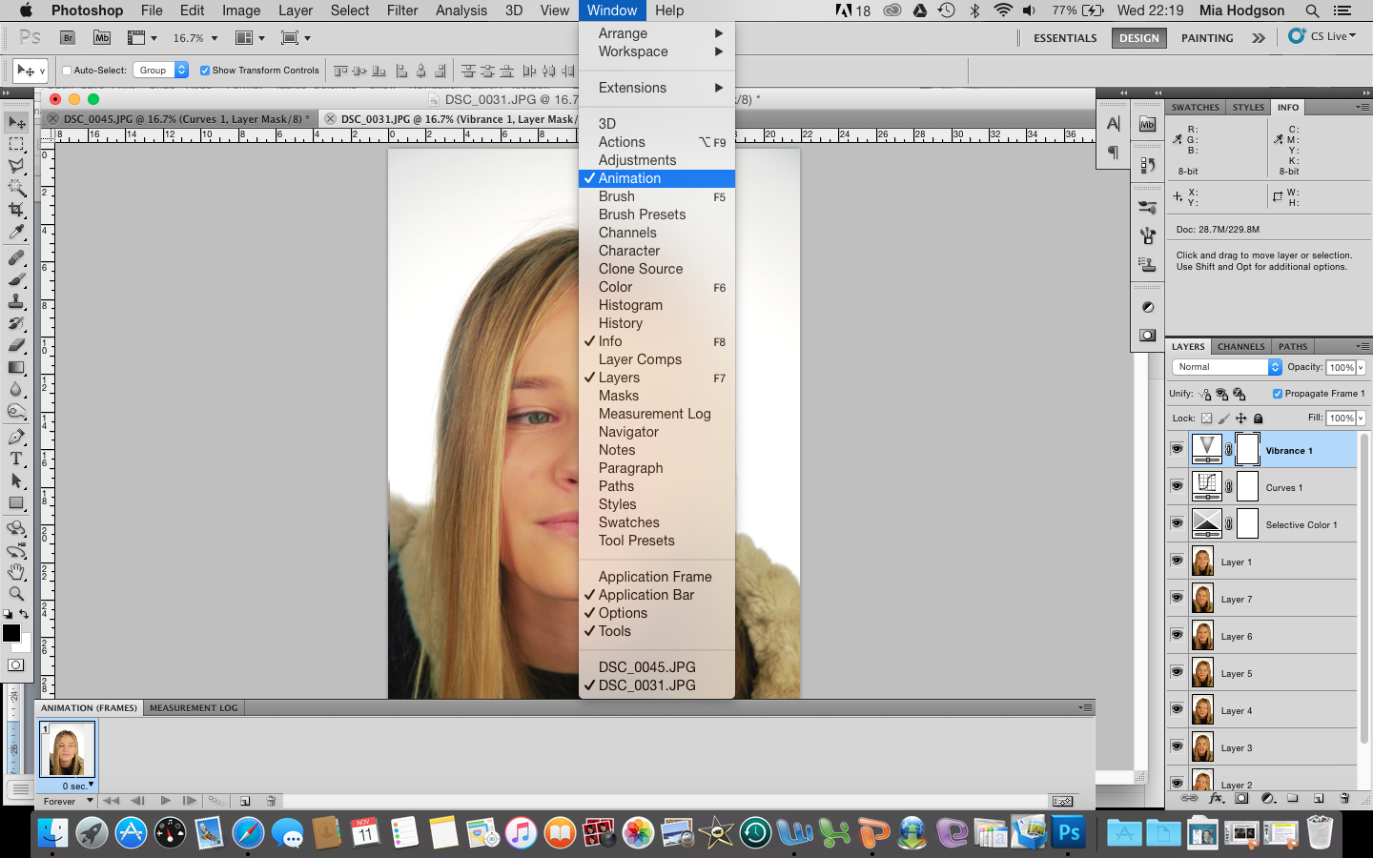

- On this new toolbar, there is an icon called “duplicates selected frames”. Click this to create the number of frames you want in your GIF – frames are the still images shown in the animation. With this example, there are 8 separate images, and so I want 8 new frames.

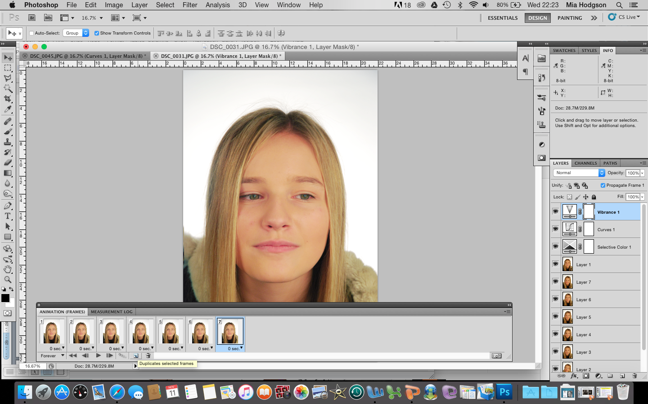

- Next, you need to decide what you want to be shown on each frame. Do this by clicking on your frames, and revealing / hiding the layers on the right (do this by clicking on the eye icon on each layer). Below is a series of images showing what I am revealing or altering with each frame.

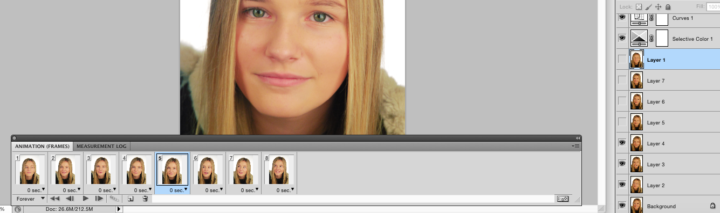
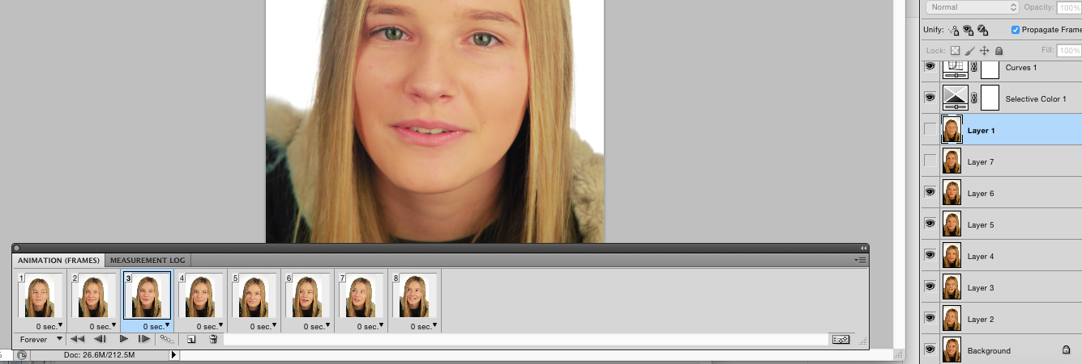
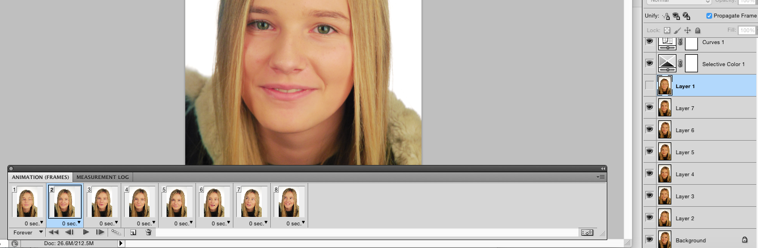
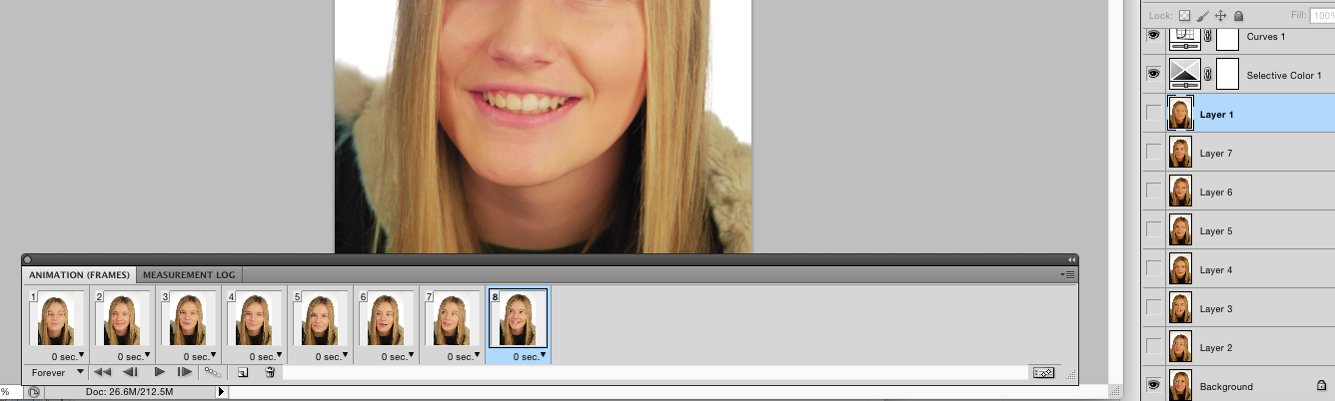

- Finally, click on the time on each frame and change it to the speed you want your image to change into the next. 0.1 to 0.5 are good values to use, as this means your photos will change quickly and create a flow. I always put the last frame to a longer timing so that there is a pause at the end of the sequence.

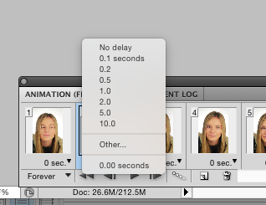

To check your GIF, press the play icon on this toolbar. Make any adjustments that may be needed.

TO SAVE YOUR GIF:
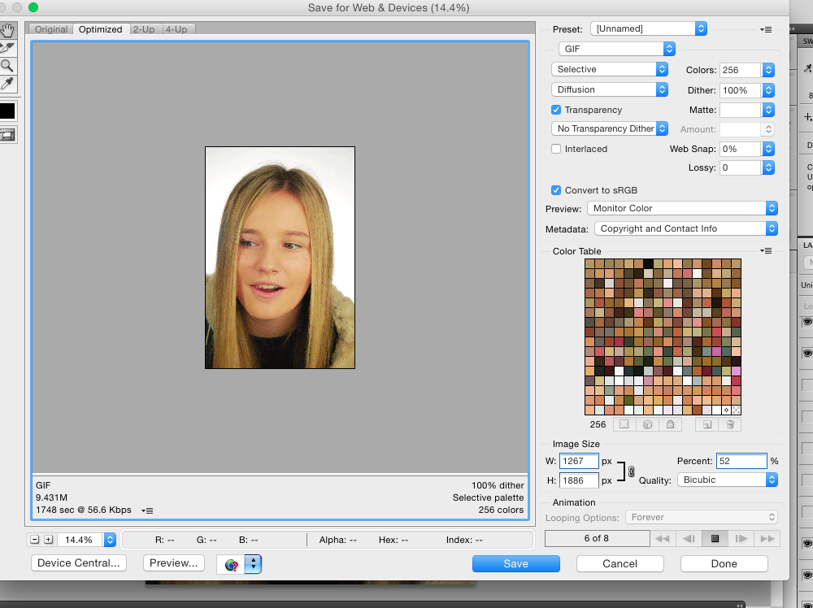
Go to “file” and select “Save for Web Devices”.

Make sure the shown settings are correct on your display:

Your file size must be no more the 10MB or else it won’t upload to weebly. if it is too big, then adjust the pixel or percentage size on the right.

You must set the “looping options” to forever or else it won’t play continuously.

